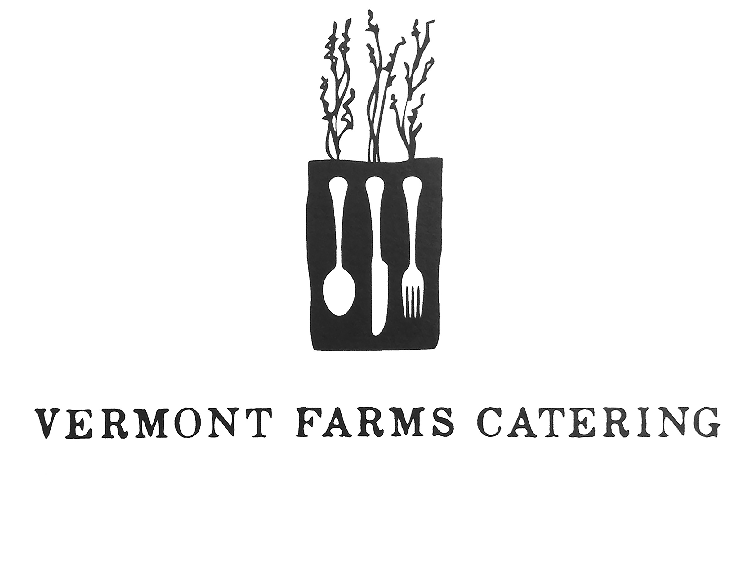
Rehearsal Dinner Buffet
July 18th, 2015

TO START

Shaved Market Vegetable Salad
Lemon-Honey Vinaigrette

THE MAIN EVENT

Herb-Roasted Misty Knoll Chicken

ON THE SIDE

Braised Greens with Chili & Garlic
&
Orange-Cumin Sweet Potatoes

Served with freshly baked Red Hen Baking Company bread
and cultured butter

TO FINISH

Basil Ginger Macaroons

Freshly Brewed Coffee & Artisanal Tea Service
Served with Farm Fresh Cream & Sweet Georgia P’s Honey

