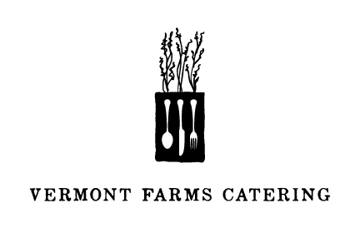
Congratulations, that’s a wrap!
3.21.2014

TO START
Maple Brook Burrata
Zucchini, Basil & Olive Puree

THE MAIN EVENT
Rigatoni with Kale & Walnut Pesto

A SWEET FINISH
Buttermilk Panna Cotta
Ruby Red Grapefruit & Ginger

For more information, please visit
www.vermontfarmscatering.com
or call 973.960.1655

