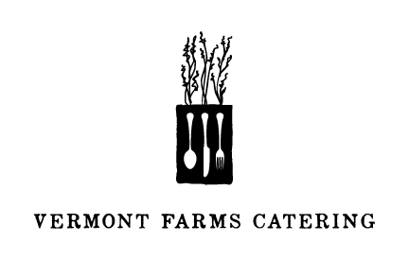
Summer Cooking Class 8.6.2014

TO START

Summer Bean Salad with Pest0 & Dried Apricots

THE MAIN EVENT

Lemon & Rosemary Grilled Chicken
Summer Vegetables, Roasted Tomato & Balsamic

DESSERT

Vegan Chocolate Cake, Coconut Whipped Cream
Marinated Strawberries

