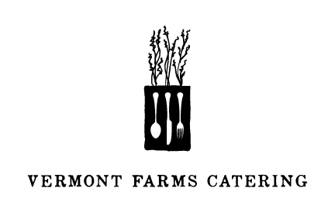

WELCOME TO #PerfectVT
4.26.2014

TO START

Asparagus & Arugula Salad
Shaved Parmesan

THE MAIN EVENT

Slow Roasted Pork Loin
Soft Polenta, Fennel & Plum Jam

DESSERT

Basil & Berry Pavlova

Chef/Partner Kevin Lasko
Event Director/Partner Katie Stiles

Thank you for joining us this weekend.

www.vermontfarmscatering.com

