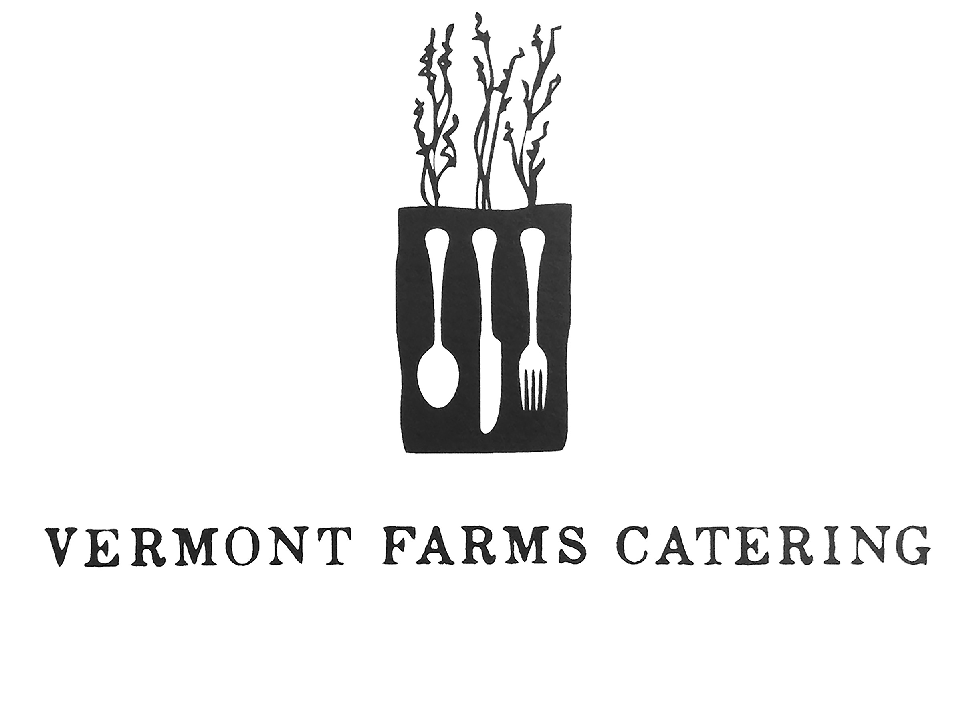
Cocktail Hour & Wedding Buffet
November 1st, 2014

COCKTAIL HOUR

PASSED HORS D’OEUVRES

Parmesean Fritters
Crispy Artichokes, Malt Vinegar Aioli
Mini Cheeseburgers
Butternut Squash Arancini

STATIONED DISPLAYS

Green Mountain Cheeses
An assortment of the finest local cheeses served with fresh fruit, house-made preserves, spiced nuts and artisanal country bread

BUFFET STYLE DINNER

Housemade Gnocchi
Fresh Corn and Summer Truffles

Heirloom Tomato & Burrata
Aged Balsamic, English Muffin Croutons, Basil

Local Filet Mignon
Brussels Sprouts, Pear-Parsnip Puree

Crispy Roasted Chicken
Farro Risotto, Swiss Chard

Dinner Served with Housemade Artisanal Country Bread & Farm Butter

TO FINISH

Coffee and Tea
Artisanal Selection of Teas & Coffee

Dessert Bar
Housemade Cookies, Selection of locally made ice creams

