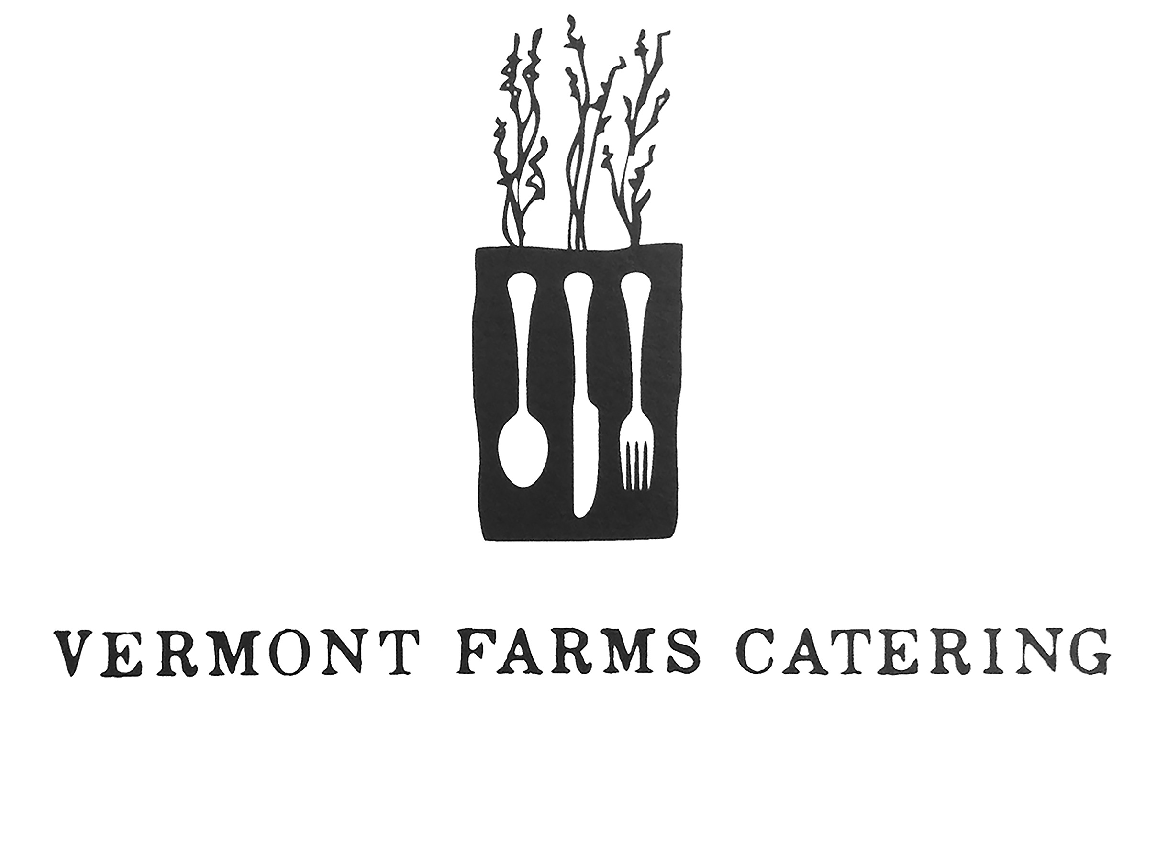
Farewell Brunch
October 5, 2014

BRUNCH BUFFET

Freshly Squeezed & Pressed Juices
OJ
Grapefruit
Spiced Apple Cider

Teas & Coffee
Artisanal Selection of Teas & Coffees
Served with Fresh Cream, Sweet Georgia P’s Honey and Sugar

A Selection of Housemade Pastries
Old Fashioned Cinnamon Sugar Donut
Cranberry Orange Muffins
Zucchini & Apricot Bread
Hearty 10-Grain Loaf
Served with Farm Butter and Jams, Jellies, Preserves & Marmalades

Boards
Scottish Smoked Salmon
Norwegian Smoked Salmon, accompanied by Crème Fraiche, Red Onion, Capers, Rye Bread, Cream Cheese

The Main Event
Farm Fresh Scrambles
Kale & Goat Cheese Frittata
Ricotta-Lemon Pancakes, Blueberry Compote
OGS Famous Home Fries
Applewood Smoked Bacon

